Aristos Athens

ME 182

Transportation Planning Assignment

***Scenario 1:****Claire lives in Seattle. Like the average driver, she drives approximately 33 miles per day. (To simplify your calculations, you can assume that she drives exactly 33 miles each day.) She likes to lease her cars, and has only one concern: keeping her monthly costs low. Her employer recently put in an electric vehicle charging station that is free for her to use. She’s intrigued by the possibility of paying $0 for fuel, but doesn’t know whether this will actually save her money. Based on monthly cost alone (effective lease price plus current fuel costs), what make and model of car should Claire lease?*

*Sensitivity Analysis*

*While Claire currently drives an average of 33 miles per day, it’s possible that, in the future, she will drive more or less. At current fuel costs, will your answer change if she drives more or less? For what range of average miles per day (e.g., “10 to 50 miles per day”) does your answer hold true, and what should Claire do if she find herself regularly going outside of this range (at either end)?*

*Similarly, it’s not only likely, but guaranteed, that fuel costs will fluctuate. For what range of fuel costs does your answer hold true, and what should Claire do if fuel costs regularly go outside this range (at either end)? Based on fuel cost trends in Seattle, how likely do you think this is? Finally, while Claire’s boss is providing free electricity for now, it's possible that he’ll charge for it in the future. At what price per kWh of electricity would your answer change (if any)?*

**Assumptions about Claire**

I will assume that Claire is a model driver. She does not get into any accidents, and does not need to pay for any repairs. I will assume she has an average credit score, so she is gets the national average APR. She is getting average Seattle rates for things like gas, electricity, auto insurance, etc.

I will assume Claire does not get a charging station installed in her home, and only uses the one at work.

If Claire really wanted to minimize her monthly costs, she could lease a low end, used car that has an extremely low value. However, I am going to assume that Claire is leasing a new vehicle.

**Assumptions about Lease**

Most car leases are between 24 and 48 months, with the average being around 36.[1]Our numbers will change depending on the length of Claire’s lease. For our analysis we will use a lease length of 36 months. (https://www.edmunds.com/car-leasing/leasing-is-back-with-some-new-twists.html)

I will assume that Claire is paying her lease based on the MSRP of the car, and that she did not negotiate a different sales price for the car. I will assume Claire get’s the US average APR of 4.4% based on an analysis by WalletHub.[2]

**Depreciation**

A key parameter in lease agreements is the expected depreciation, or how much value we expect the car to lose over the course of the lease. Reportedly, a major drawback with leasing EVs is that they depreciate quickly. This is due to how new the EV market is. Rapid change in technology means each new edition of an EV model is more efficient and cheaper than the previous. This in turn drives down the price of older EV models. The only company that is mostly immune to this trend are Teslas. This is likely due to low availability. Teslas have high resale value regardless of model.

*However*, further investigation seems to suggest EVs are do *not* depreciate much faster than conventional vehicles. The supposedly large price differences between new and used do not take into account the governmental incentives offered on *new* EVs. As an example, NADA reported the average 2011 Chevy Volt lost $21,000 in value over two years, a huge number.[3] However, a consumer buying a new Chevy Volt was getting close to $10,000 in government subsidies in tax breaks. Effectively, they only depreciated $11,000, slightly above the average depreciation rates of conventional vehicles. These articles by AutoTrader and Clean Technica support this understanding.[4],[5]

Therefore, when for analyzing any vehicle for Claire I will assume average depreciation of around 16% per year for IC vehicles and 20% for EV/Hybrid vehicles. I will then check to see if this matches current prices for that particular vehicle.[6]

**Table 1. Prices in Seattle, Washington**

|  |  |
| --- | --- |
| Cost of Gas in Washington State[7] | $2.932/gal |
| Cost of Electricity (Residential) in Washington State[8] | $0.1013/kWh |
| Cost of Electricity (Commercial) in Washington State8 | $0.0855/kWh |

**Table 2. Government Incentives**

|  |  |
| --- | --- |
| Incentive | Value |
| No emissions test required for EV and Hybrid vehicles[9] | Emissions tests are required once every 2 years in Seattle. Average cost: $15.00[10] |
| 10% Reduction in Auto Insurance9 | Average Washington auto insurance is $1,499 annually[11], so 0.1*1499 = $149.90 savings |
| Federal one-time tax-credit for private EV and Hybrid Vehicles[12] | $2,500-7,500. Varies based on vehicle. |
| Washington sales tax exemption. Valid for the first $32,000 of the vehicle’s value, whether this be selling price or lease payments.[13] There is a limit on 7,500 vehicles that will get this exemption, but as of late 2017 this limit has not been reached.14 | Washington vehicles sales tax is a flat 6.5%.[14]  Monthly Savings: 0.065*Lease Payment  Total Savings: 0.065*32,000 = $2,080 |

**Initial Analysis**

To find Claire’s total monthly payment, we need to find the amount she spends on gas per month plus the cost of her lease each month.

The cost of gas is simply the number of miles * 1/the fuel efficiency * the price of gas.

Finding the cost of the lease takes a few more steps. First, we find the Residual Value, or how much the car will be worth after 3 years. I use a deprecation rate of 15% per year. Next we assume Claire does not negotiate, and uses the MSRP of the car as the selling price. We use $1000 in fees, and a $1500 down payment. Our Adjusted Capitalized Cost = MSRP + Fees – Down Payment. Our Depreciation = MSRP – Residual Value. The lease base payment is the Depreciation/Lease Months. The Rent Charge = APR*Adjusted Capitalized Cos).

To compare many cars, I created an excel sheet with the best performing cars of 2017, based on data from Consumer Reports (See **Fig 1**). “Best Performing” includes the best hybrids, best EVs, as well as conventional vehicles with lowest cost, and conventional vehicles with best MPG. I then import this spreadsheet into MatLab and found the monthly cost of each vehicle (See **Appendix**).

With the standard conditions of free electricity, 33 miles per day, and gas costing $2.90/gal, Claire should choose: **2017 Ford Focus EV**. At 33 mi/day, her monthly payment will be **$379.09**. This choice holds if Claire is driving **23-100 miles per day** (See **Fig 2**). This vehicle wins out because of the relatively high cost of gas in Seattle and the numerous tax/insurance incentives available in Washington. It is the cheapest EV, with an MSRP of $29,120 (The cheaper Electric SmartCar doesn’t get the same tax breaks). It has decent range at 100 miles, and boasts 100 mi per 31 kWh, a figure only Teslas can beat.

If Claire gets free electricity and gas costs the same $2.90/gal, but she drives less than 23 miles per day, she should choose: **2017 Nissa Versa**. At 22 mi/day, her monthly payment would be **$376.95**. This choice holds if Claire is driving **1-22 miles per day** (See **Fig 3**). This vehicles wins out for short distance driving because it is so much cheaper than its competitors. The Nissan Versa is the cheapest new car available from major manufacturers in the United States.

For different combinations of gas prices and miles per day, there are 5 vehicles that are good choices for Claire. They are the Ford Focus EV, Fortwo Smartcar, Nissan Versa, Volkswagen eGolf EV, and Hyundai Ioniq EV (see Fig 2-6).

**Paid Electricity Analysis**

If Claire has to pay for electricity, she should choose the **2017 Nissan Versa** (see **Fig 7**). At 33 mi/day, $2.90/gal gas, and $0.1013/kWh electricity, her monthly Payment would be: **$404.29**. This decision holds if Claire is driving **0-36 miles per day**.

If Claire drives **37-110 miles per** day with $2.90/gal gas, and $0.1013/kWh electricity, she should choose the **Hyundai Ioniq EV** (see **Fig 8**)

**Sensitivity Analysis**

Claire’s monthly cost is strongly correlated with the price of gasoline and the number of miles she drives per day. Her costs does not vary as strongly with electricity. The price of electricity influences the cut-off points that determine where she should choose an EV versus a conventional vehicle. However, when she chooses an IC vehicle, the price of electricity does not add to her monthly cost. When she chooses an EV vehicle, the price of electricity does not add very much to her monthly cost. This is because cost of electricity per mile is much cheaper than the cost of gasoline per mile. **Figures 12-14** are contour graphs of Claire’s monthly cost versus 2 variables, with the 3rd variable held constant. If Claire drives 33 mi/day and gas costs $2.90/gal gas, the point at which she should switch between the EV and IC options is when electricity costs **~$0.085/kWh**. We can see this in **Fig 14**; between X = 8 and X = 9, the contour goes horizontal, meaning that above X ~8.5 the price of electricity has no effect on monthly payments. This indicates that we have switched to the IC choice at this point.

Similarly, we can find the point at which Claire should switch between EV and IC based on the price of gas (assuming free electricity). If we look at **Figure 12**, we can see that there is a huge gap in contour lines when the price of gas goes above **$2.10**. This gap indicates that if the price of gas went below $2.10 per gallon, Claire should switch to an IC (for 33 mi/day, free electricity). Note that this gap in contour lines does *not* mean a jump in price (which would mean our analysis is faulty). The gap indicates that past the $2.10 price point the price of gas does not have a significant effect on monthly payments. The location of the higher horizontal contour lines are determined by the x-value (price of gas) at the y-value (miles driven) that the switch between IC and EV occurs.

**Conclusions**

We made important assumptions in this analysis. Among them, that Claire is completely average in driver history and credit score, which affects the cost of her lease and auto insurance. We also assumed that if Claire got an EV, she would not have to pay for potentially expensive installation of charging equipment. We also assumed Claire was only interested in new vehicles. If not, perhaps she could have leased a $2000 used car, which would greatly reduce her monthly payments.

Claire’s decision is a pretty close call between the Ford Focus, the cheapest EV, and the Nissan Versa, the cheapest IC. In most states Claire should go with the Versa, but in Washington there are large financial incentives for going EV, including the waiving of sales tax, reduction in car insurance price, and large one-time tax credits. Claire’s choice is dependent on the price of gas, the number of miles she drives daily, and, to a lesser extent, the price of electricity.

**Figures for Question 1**

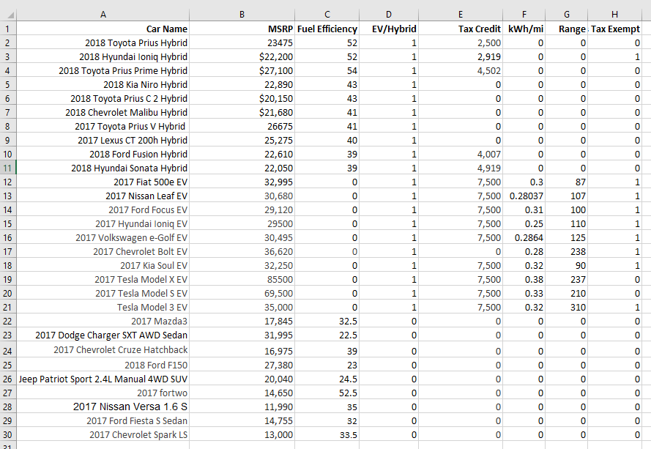

**Fig 1 -** Screenshot of excel file containing vehicle information. All data comes from Consumer Reports.

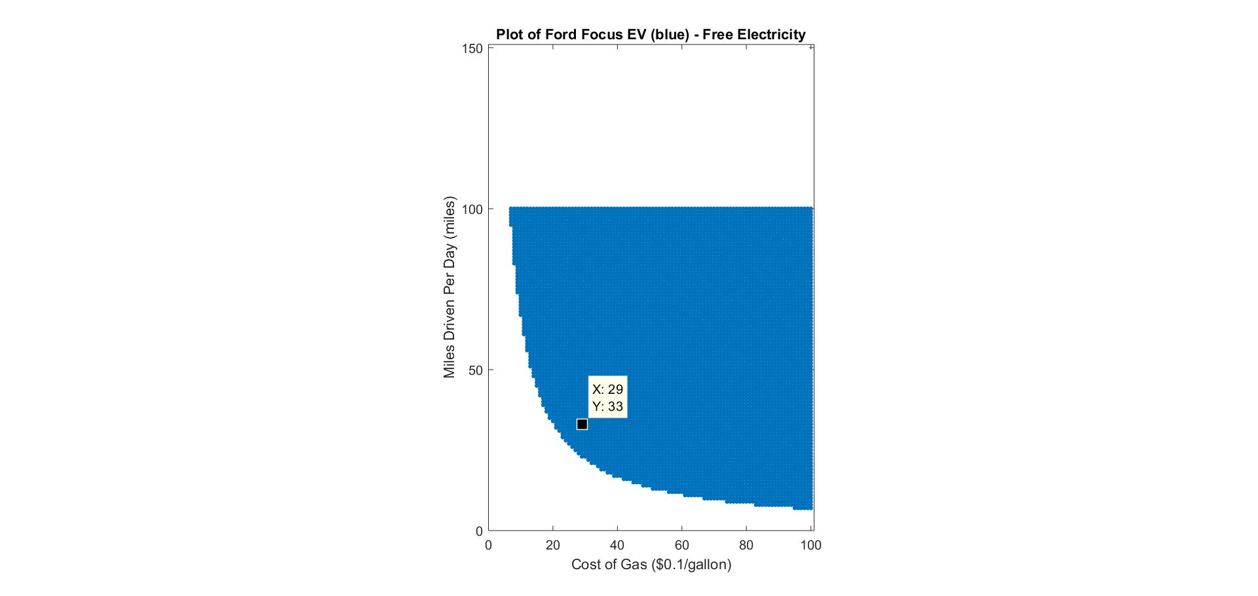

**Fig 2**

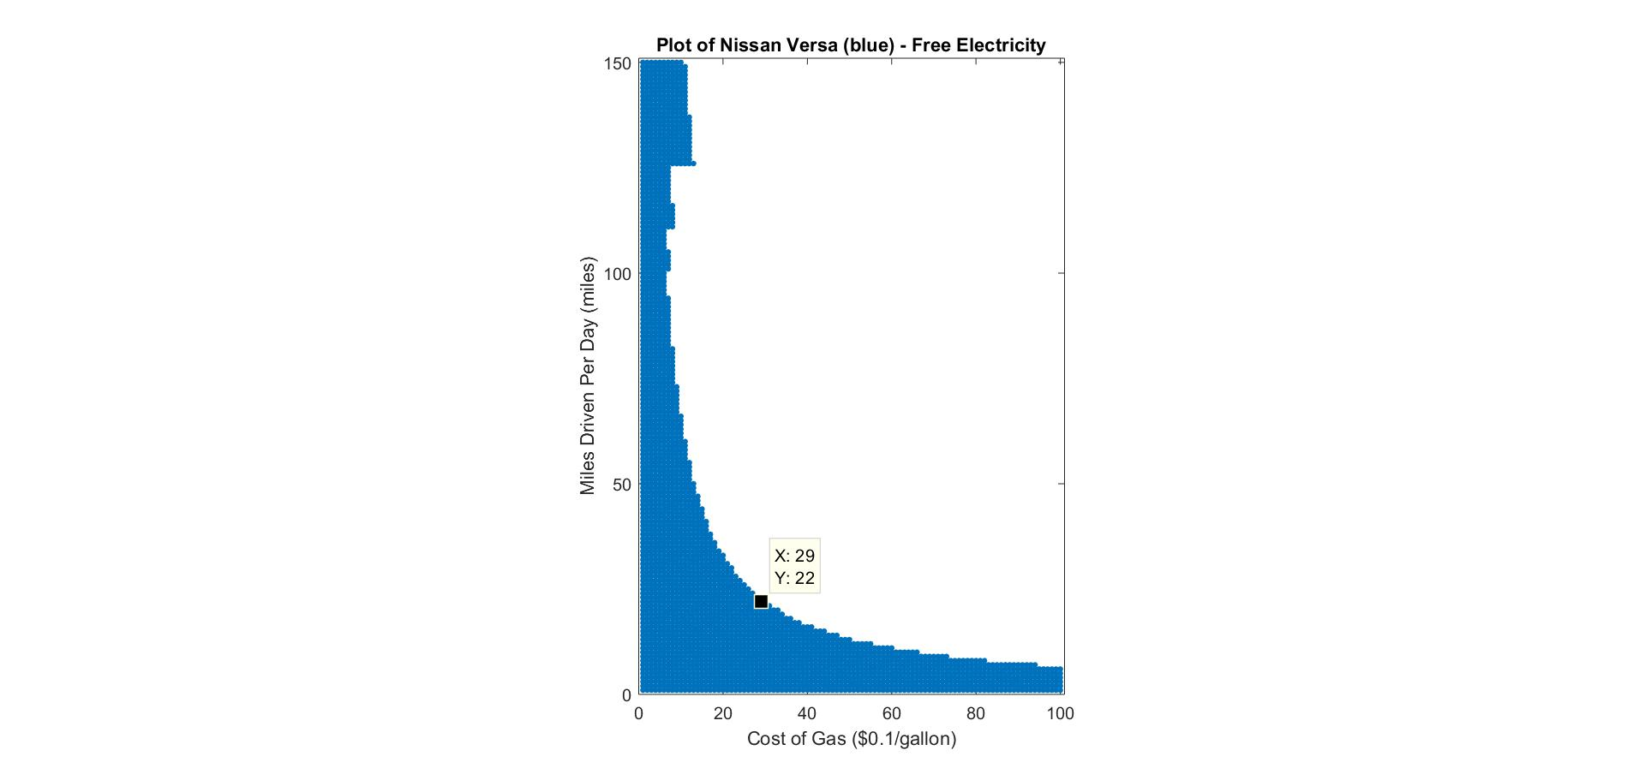

**Fig 3**

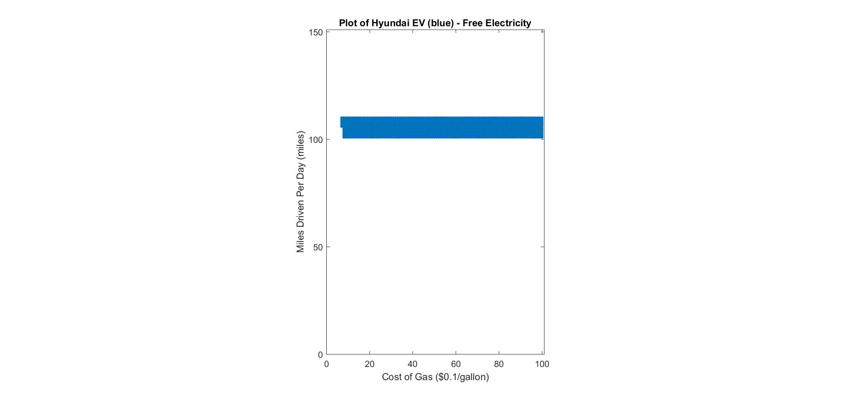

**Fig 4**

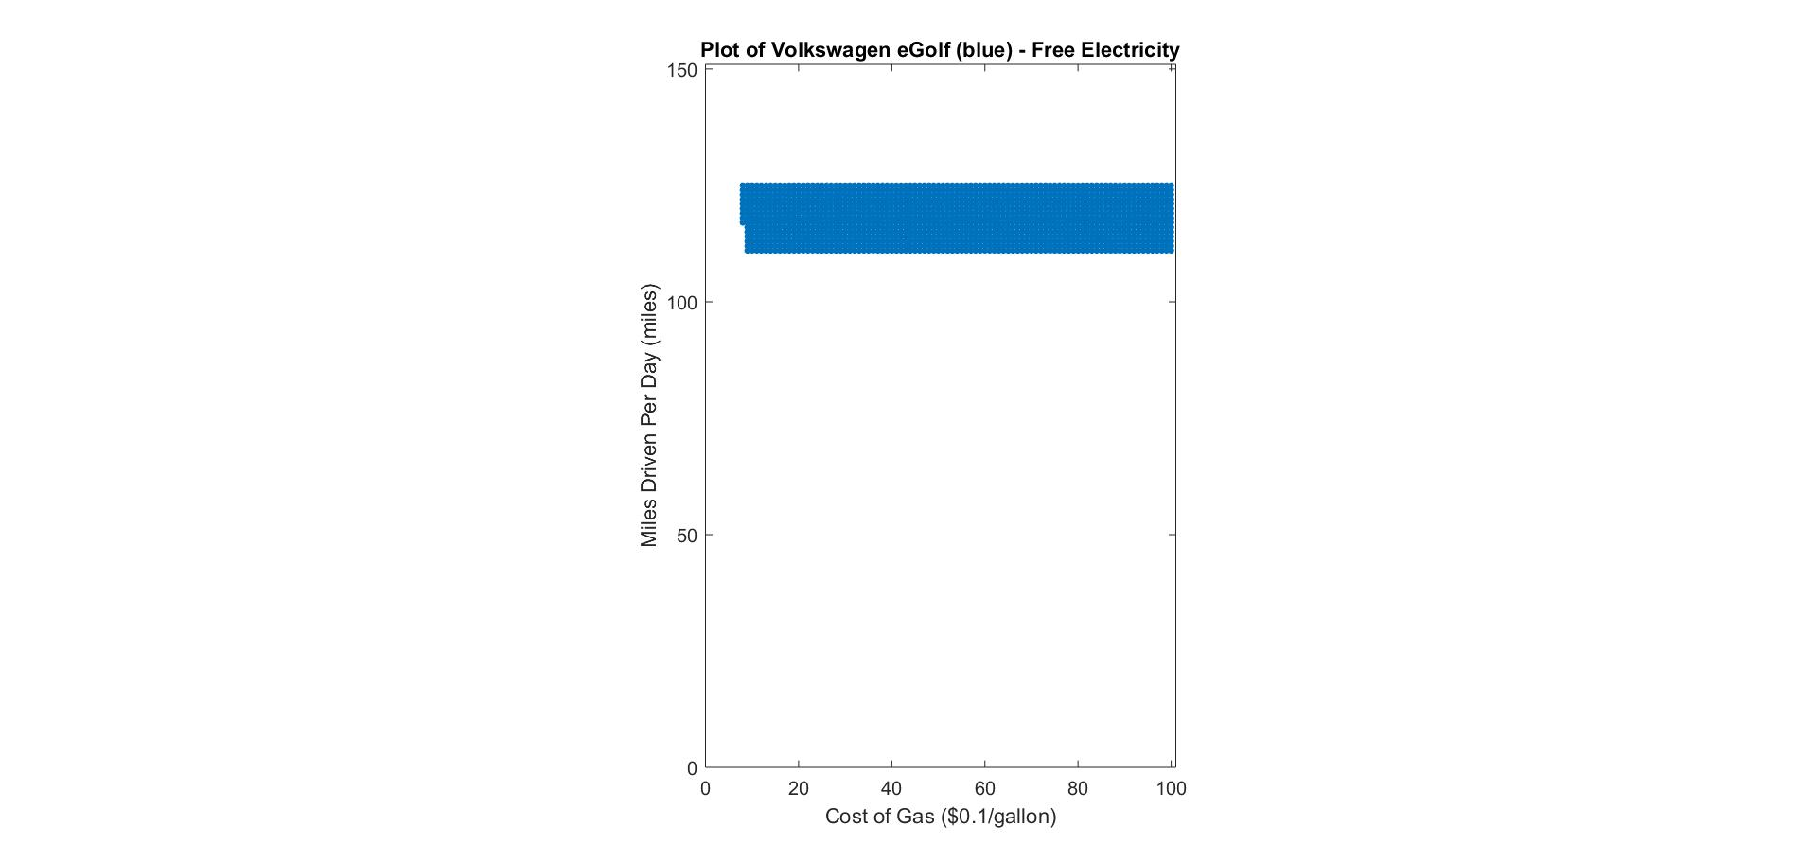

**Fig 5**

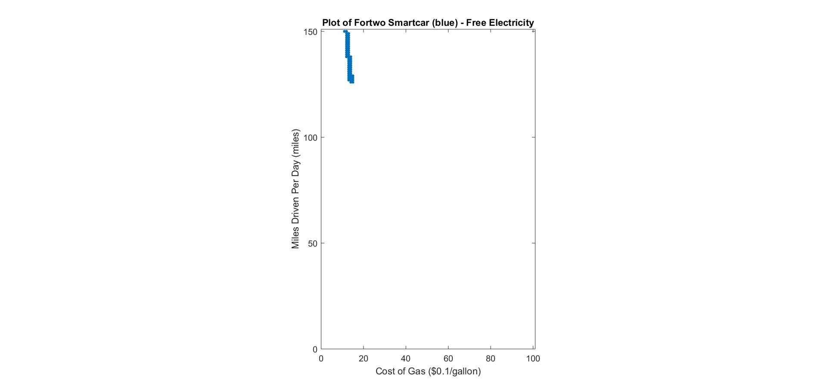

**Fig 6**

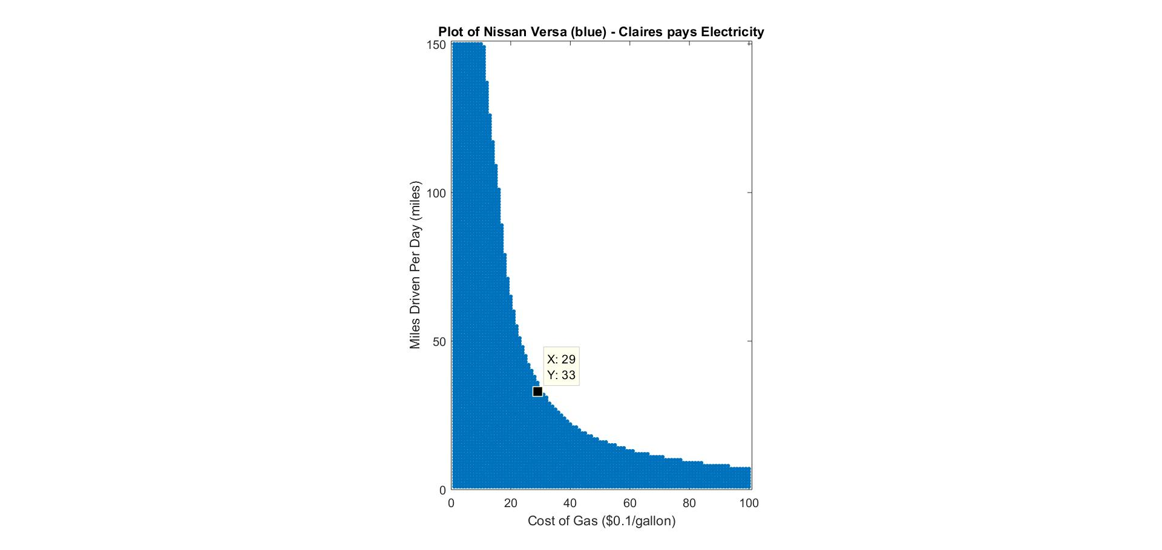

**Fig 7**

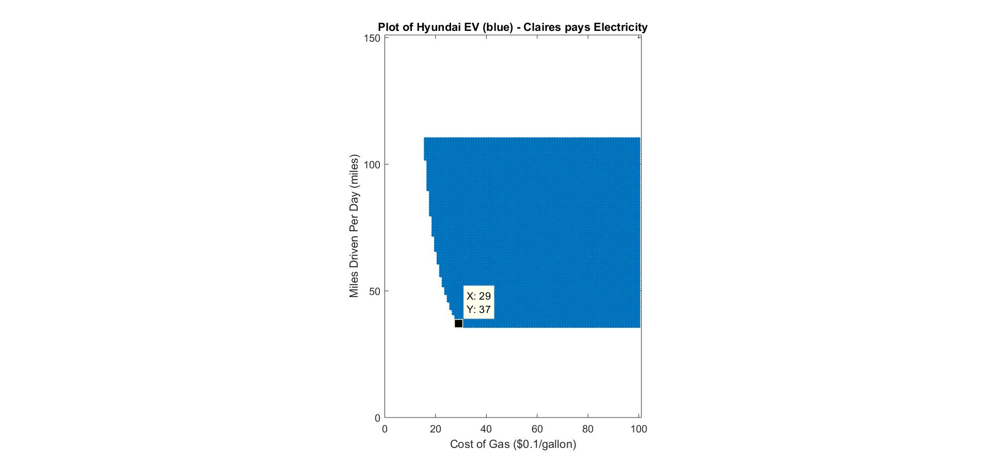

**Fig 8**

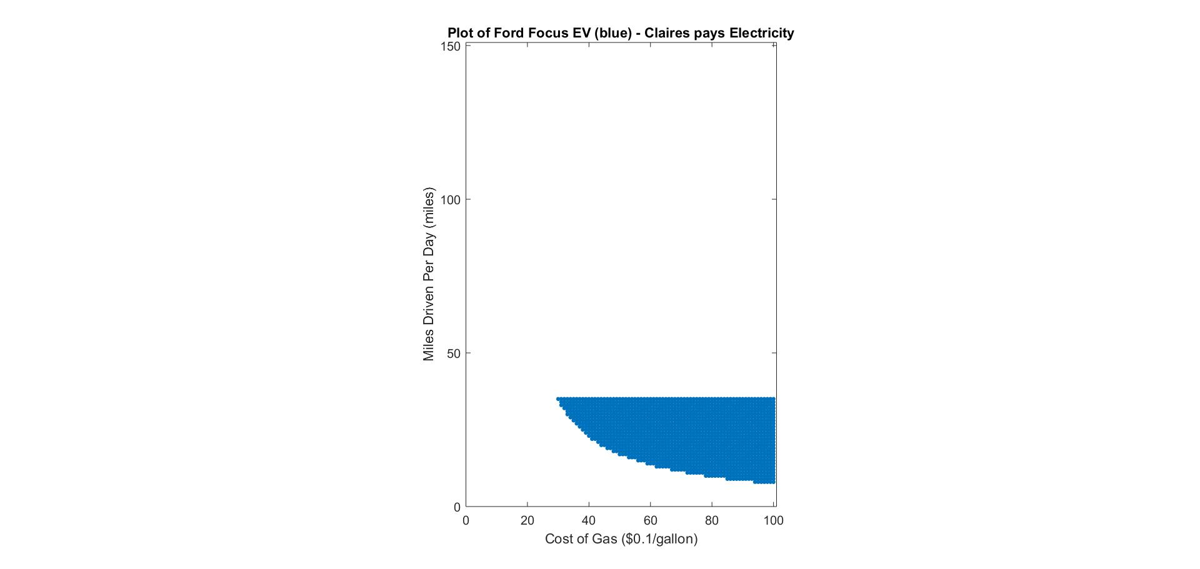

**Fig 9**

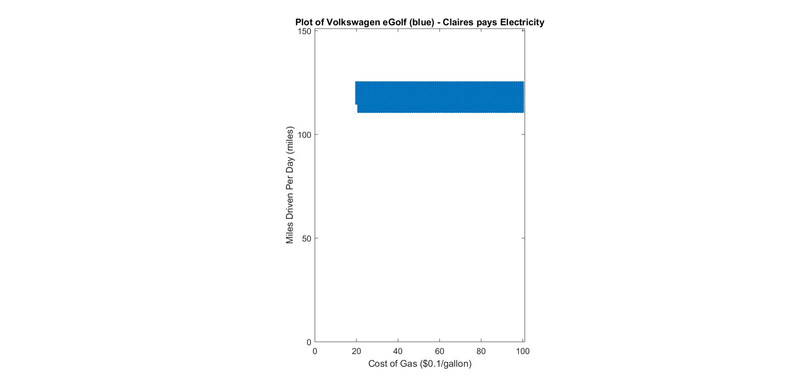

**Fig 10**

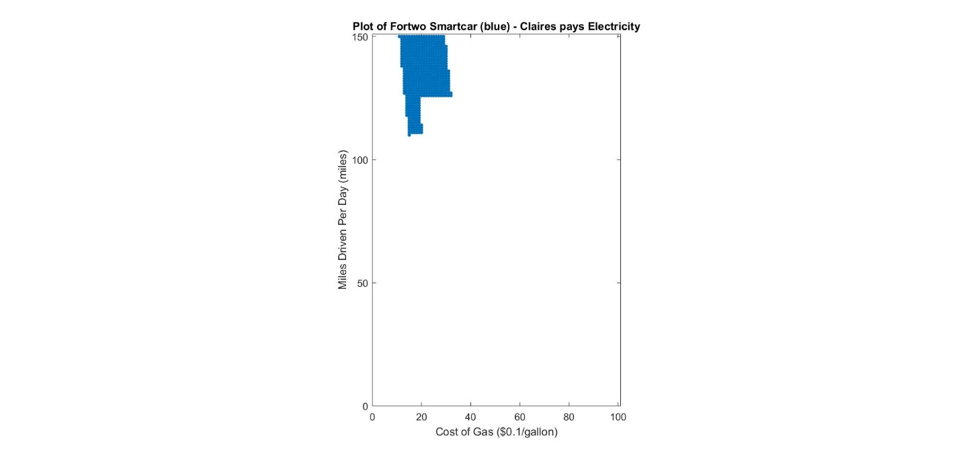

**Fig 11**

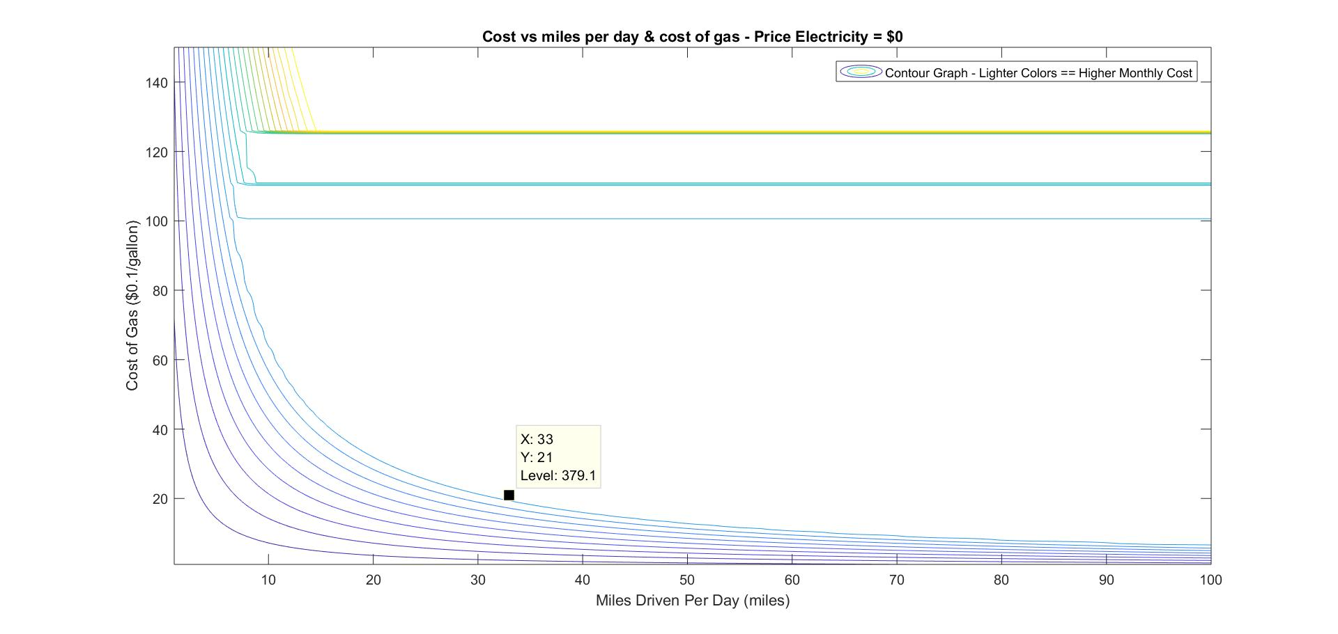

**Fig 12**

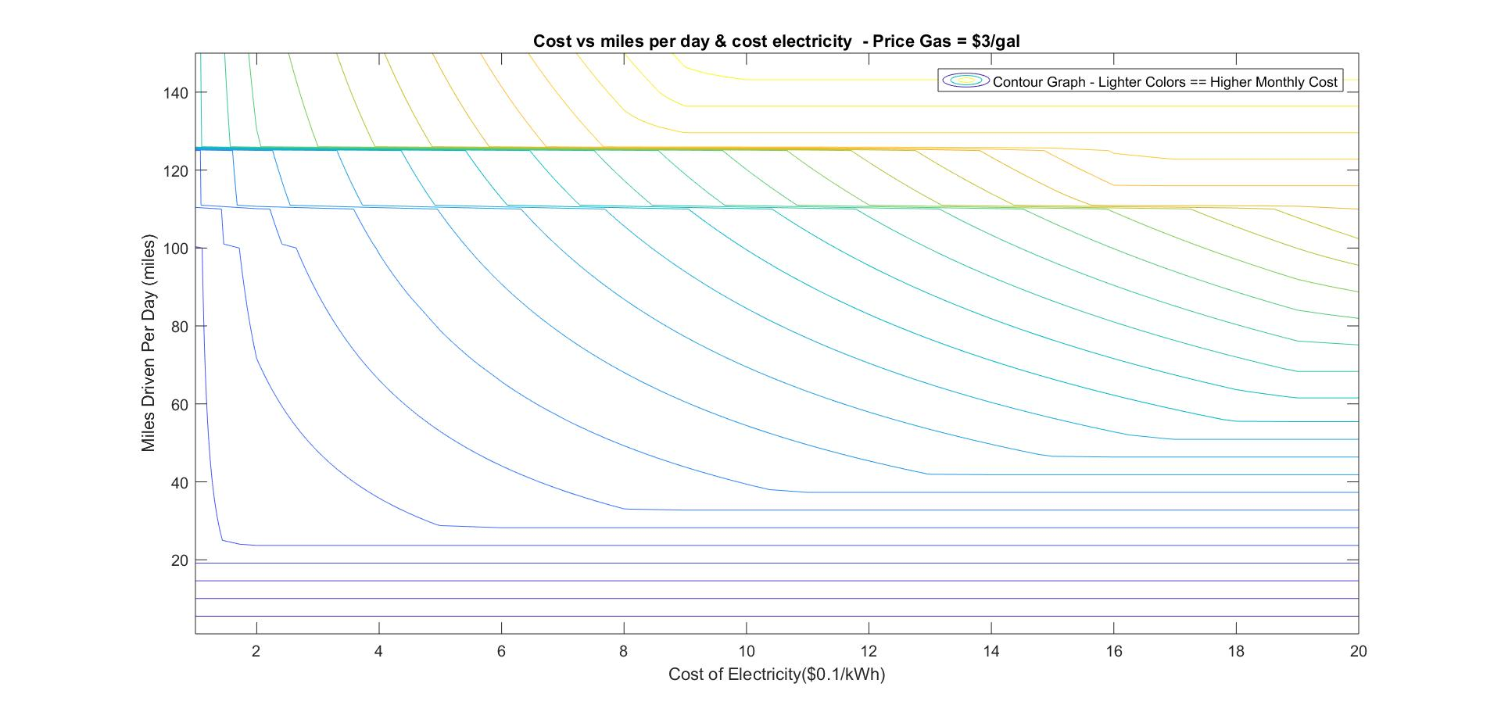

**Fig 13**

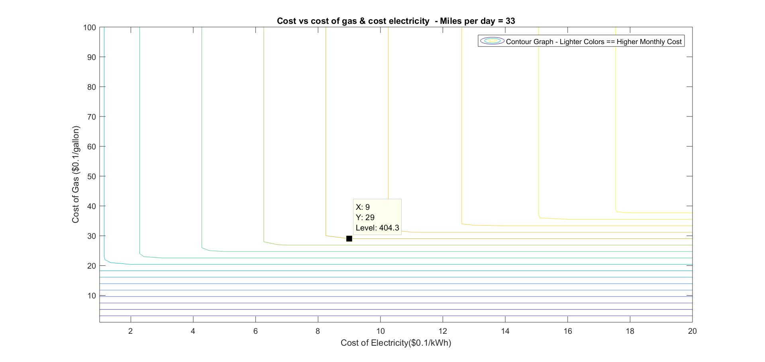

**Fig 14**

**Appendix Question 1**

## **Question 1 Main Script - Loops & Graphs**

%Aristos Athens  
%ME 182  
%Transportation Planning Assignment  
  
clear all  
clc  
close all

## Claire + Lease Info

leaseMonths = 36;  
depreciationRate = 0.15;

## Analysis

[data,carNames] = xlsread("Vehicles_Price_Comparison.xlsx");  
carNames = carNames(2:length(carNames),1);  
carNames = string(carNames);  
cellArray = {};  
  
for milesPerDay = 1:150  
 for gasCostPerGallon = 1:100  
 for costElectricity = 1:20  
  
 sortedData = findMonthlyPayment(data,carNames,milesPerDay,gasCostPerGallon,costElectricity,leaseMonths,depreciationRate);  
 sortedData{1,3} = sortedData{1,1}(1);  
 sortedData{1,4} = sortedData{1,2}(1);  
 cellArray{milesPerDay,gasCostPerGallon,costElectricity} = sortedData;  
  
 milesVec(milesPerDay,1) = milesPerDay;  
 gasVec(gasCostPerGallon,1) = gasCostPerGallon;  
 electricityVec(costElectricity,1) = costElectricity;  
 costData(milesPerDay,gasCostPerGallon,costElectricity) = sortedData{1,3};  
 carNameData(milesPerDay,gasCostPerGallon,costElectricity) = sortedData{1,4};  
  
 end  
 end  
end  
x = unique(carNameData);  
carNameDataNissan = carNameData == "2017 Nissan Versa 1.6 S";  
carNameDataVolks = carNameData == "2017 Volkswagen e-Golf EV";  
carNameDataHyundaiEV = carNameData == "2017 Hyundai Ioniq EV";  
%carNameDataHyundaiHybrid = carNameData == "2018 Hyundai Ioniq Hybrid";  
carNameDataFordFocusEV = carNameData == "2017 Ford Focus EV";  
carNameDataSmartCar = carNameData == "2017 fortwo";  
  
n = 25;  
  
figure  
contour(squeeze(costData(:,:,1)),n);  
title("Cost vs miles per day & cost of gas - Price Electricity = $0")  
xlabel("Miles Driven Per Day (miles)");  
ylabel("Cost of Gas ($0.1/gallon)");  
legend("Contour Graph - Lighter Colors == Higher Monthly Cost");  
  
figure  
contour(squeeze(costData(:,29,:)),n);  
title("Cost vs miles per day & cost electricity - Price Gas = $3/gal")  
xlabel("Cost of Electricity($0.1/kWh)");  
ylabel("Miles Driven Per Day (miles)");  
legend("Contour Graph - Lighter Colors == Higher Monthly Cost");  
  
figure  
contour(squeeze(costData(33,:,:)),n);  
title("Cost vs cost of gas & cost electricity - Miles per day = 33")  
xlabel("Cost of Electricity($0.1/kWh)");  
ylabel("Cost of Gas ($0.1/gallon)");  
legend("Contour Graph - Lighter Colors == Higher Monthly Cost");  
  
  
  
figure  
spy(squeeze(carNameDataNissan(:,:,1)))  
title("Plot of Nissan Versa (blue) - Free Electricity")  
xlabel("Cost of Gas ($0.1/gallon)");  
ylabel("Miles Driven Per Day (miles)");  
set(gca,'Ydir','normal')  
  
figure  
spy(squeeze(carNameDataVolks(:,:,1)))  
title("Plot of Volkswagen eGolf (blue) - Free Electricity")  
xlabel("Cost of Gas ($0.1/gallon)");  
ylabel("Miles Driven Per Day (miles)");  
set(gca,'Ydir','normal')  
  
figure  
spy(squeeze(carNameDataHyundaiEV(:,:,1)))  
title("Plot of Hyundai EV (blue) - Free Electricity")  
xlabel("Cost of Gas ($0.1/gallon)");  
ylabel("Miles Driven Per Day (miles)");  
set(gca,'Ydir','normal')  
  
figure  
spy(squeeze(carNameDataFordFocusEV(:,:,1)))  
title("Plot of Ford Focus EV (blue) - Free Electricity")  
xlabel("Cost of Gas ($0.1/gallon)");  
ylabel("Miles Driven Per Day (miles)");  
set(gca,'Ydir','normal')  
  
figure  
spy(squeeze(carNameDataSmartCar(:,:,1)))  
title("Plot of Fortwo Smartcar (blue) - Free Electricity")  
xlabel("Cost of Gas ($0.1/gallon)");  
ylabel("Miles Driven Per Day (miles)");  
set(gca,'Ydir','normal')  
  
  
  
  
figure  
spy(squeeze(carNameDataNissan(:,:,10)))  
title("Plot of Nissan Versa (blue) - Claires pays Electricity")  
xlabel("Cost of Gas ($0.1/gallon)");  
ylabel("Miles Driven Per Day (miles)");  
set(gca,'Ydir','normal')  
  
figure  
spy(squeeze(carNameDataVolks(:,:,10)))  
title("Plot of Volkswagen eGolf (blue) - Claires pays Electricity")  
xlabel("Cost of Gas ($0.1/gallon)");  
ylabel("Miles Driven Per Day (miles)");  
set(gca,'Ydir','normal')  
  
figure  
spy(squeeze(carNameDataHyundaiEV(:,:,10)))  
title("Plot of Hyundai EV (blue) - Claires pays Electricity")  
xlabel("Cost of Gas ($0.1/gallon)");  
ylabel("Miles Driven Per Day (miles)");  
set(gca,'Ydir','normal')  
  
figure  
spy(squeeze(carNameDataFordFocusEV(:,:,10)))  
title("Plot of Ford Focus EV (blue) - Claires pays Electricity")  
xlabel("Cost of Gas ($0.1/gallon)");  
ylabel("Miles Driven Per Day (miles)");  
set(gca,'Ydir','normal')  
  
figure  
spy(squeeze(carNameDataSmartCar(:,:,10)))  
title("Plot of Fortwo Smartcar (blue) - Claires pays Electricity")  
xlabel("Cost of Gas ($0.1/gallon)");  
ylabel("Miles Driven Per Day (miles)");  
set(gca,'Ydir','normal')

[*Published with MATLAB® R2017b*](http://www.mathworks.com/products/matlab)

## **Function - Find Monthly Payment for each car**

function sortedData = findMonthlyPayment(data,carNames,milesPerDay,gasCostPerGallon,costElectricity,leaseMonths,depreciationRate)

## Claire + Lease Info

gasCostPerGallon = gasCostPerGallon/10;  
if (costElectricity == 1)  
 costElectricity = 0;  
else  
 costElectricity = costElectricity/100;  
end

## Basic Analysis

monthlyPaymentData = [];  
  
  
for i = 1:length(data)

MSRP = data(i,1);  
 fuelEfficiency = data(i,2);  
 EV = data(i,3);  
 taxCredit = data(i,4);  
 electricEfficiency = data(i,5);  
 range = data(i,6);  
 taxExempt = data(i,7);  
  
 if (EV == 1)  
 depreciation = 0.2;  
 end

## Gas/Electricity Costs

if (fuelEfficiency == 0)  
 monthlyGasCost = 0;  
 dailyElectricityCost = milesPerDay*(electricEfficiency)*costElectricity;  
 monthlyElectricityCost = 30*dailyElectricityCost;  
 else  
 monthlyElectricityCost = 0;  
 dailyGasCost = milesPerDay*(1/fuelEfficiency)*gasCostPerGallon;  
 monthlyGasCost = 30*dailyGasCost;  
 end  
 monthlyPayment = monthlyGasCost + monthlyElectricityCost;

## Government Incentives

%Emissions Testing  
 emissionsTestCost = 15;  
 emissionsTestYearlyFrequency = 0.5;  
 emssionsYearlyCost = emissionsTestCost*emissionsTestYearlyFrequency;  
 emissionsMonthlyPayment = emssionsYearlyCost/12;  
 %Incentive: free emissions testing  
 if (EV == 1)  
 emissionsMonthlyPayment = 0;  
 end  
  
 monthlyPayment = monthlyPayment + emissionsMonthlyPayment;  
  
  
 %Insurance  
 insuranceYearlyPayment = 1499;  
 monthlyInsurancePayment = insuranceYearlyPayment/12;  
 %Incentive: 10% insurance reduction  
 if (EV == 1)  
 monthlyInsurancePayment = 0.95*monthlyInsurancePayment;  
 end  
  
 monthlyPayment = monthlyPayment + monthlyInsurancePayment;  
  
  
 %Tax Credit  
 %Spread out over 36 months  
 monthlySavings = taxCredit/leaseMonths;  
  
 monthlyPayment = monthlyPayment - monthlySavings;  
  
  
 %Sales Tax Credit  
 salesTax = 0.065*MSRP;  
 savings = min(salesTax, 0.065*32000);  
 if(taxExempt == 0)  
 savings = 0;  
 end  
 MSRP = MSRP + salesTax - savings;

## Lease

leaseYears = leaseMonths/12;  
 residualValuePercentage = (1 - depreciationRate)^leaseYears;  
 residualValue = MSRP * residualValuePercentage;  
 %Lease has $1000 in fees  
 grossCapitilizedCost = MSRP + 1000;  
 %Lease requires $1500 down payment  
 capitilizedCostReduction = 1500;  
 %Adjust the Capitilized Cost  
 adjustedCapitilizedCost = grossCapitilizedCost - capitilizedCostReduction;  
 %Find Overall Depreciation  
 depreciationAmount = adjustedCapitilizedCost - residualValue;  
 %Assume APR financing rate of 4.4%  
 APR = 0.044;  
 basePayment = (depreciationAmount/leaseMonths);  
 rentCharge = (APR/12)*(adjustedCapitilizedCost + residualValue);  
  
 monthlyPayment = monthlyPayment + rentCharge + basePayment;  
  
 if( (range ~= 0) && (range < milesPerDay))  
 monthlyPayment = 99999;  
 end  
  
 monthlyPaymentData= [monthlyPaymentData; monthlyPayment];

end  
  
  
%Sort the data in ascending order  
[sortedData,indeces] = sort(monthlyPaymentData);  
sortedCarNames = carNames(indeces);  
sortedData = {sortedData sortedCarNames};

end

[*Published with MATLAB® R2017b*](http://www.mathworks.com/products/matlab)

***Scenario 2:****Per lives in Mountain View and works as a professor at Stanford University. He wants your advice on what car he should buy next. He wants to buy an electric car, but he’s not sure this is possible within his constraints:*

* + *His daily commute is 8 miles one-way. On the weekends, he drives 30 miles per day.*
  + *Twice a year, he takes a long-distance road trip: 1) to Tahoe, and 2) to Ashland, OR.*
  + *Once a month, he flies out of SFO. He likes to drive himself to the airport and park there.*
  + *He likes to own his cars (vs. leasing), but refuses to pay more than $40,000 to buy one.*
  + *More importantly, he refuses to pay any amount of money for a car that is “ugly” (you can use your own judgment on how to interpret this).*

*What kind of car should Per buy and why? If he follows your plan, what will the upfront and yearly costs of his transportation be (based on the trips listed above, not including his airfare)?*

**Car Choice**

First, let’s check the commercially available electric vehicles. They are:

|  |  |  |
| --- | --- | --- |
| **Car Name** | **MSRP** | **Cool?** |
| Chevrolet Spark EV | $27,495 | No |
| Electric SmartCar EV | $25,825 | No |
| Fiat 500e EV | $32,995 | Maybe |
| Nissan Leaf EV | $30,680 | Maybe |
| Ford Focus EV | $29,120 | Maybe |
| Hyundai Ioniq EV | $29,500 | Maybe |
| Volkswagen e-Golf EV | $30,495 | Maybe |
| Chevrolet Bolt EV | $36,620 | Maybe |
| Kia Soul EV | $32,250 | No |
| Tesla Model X EV | $85,500 | Yes |
| Tesla Model S EV | $69,500 | Yes |

If we consider Per’s price range, we can immediately eliminate the Tesla Model S and Tesla Model X. We can also eliminate the cars that are patently uncool: the Chevy Spark, SmartCar Electric, and Kia Soul. Now the vehicles under consideration are:

|  |  |  |  |  |  |  |
| --- | --- | --- | --- | --- | --- | --- |
| **Car Name** | | | **MSRP** | | | **Range** |
| Fiat 500e EV | | | $32,995 | | | 87 |
| Nissan Leaf EV | | | $30,680 | | | 107 |
| Ford Focus EV | | | $29,120 | | | 100 |
| Hyundai Ioniq EV | | | $29,500 | | | 110 |
| Volkswagen e-Golf EV | | | $30,495 | | | 125 |
| Chevrolet Bolt EV | | | $36,620 | | | 238 |
|  |  |  | |  |

The next most important consideration here is range. One of the major drawbacks of electric vehicles is their limited range compared to conventional vehicles. We can see that none of the vehicles can make it to Ashland, 383 miles away, without stopping. The only vehicles that can make it to Lake Tahoe, 221 miles away, are Teslas and the Chevy Bolt (on a good day). We need to check the availability of charging stations. For information on charging stations I use ChargeHub, and PlugShare. For information on travel times and distances I use Google Maps.

The drive between Mountain View and South Lake Tahoe is littered with public charging stations. The largest stretch between adjacent stations is between Pollock Pines and South Lake Tahoe, which is 47 miles. Conversely, Northern California is sparsely populated, and the route has far fewer stations. There are three stretches of road that could be problematic:

Shasta Lake to Mount Shasta – 55 miles

Mount Shasta to Yreka – 38 miles

Yreka to Ashland – 49 miles

We can see that any vehicle that can handle the trip to Ashland can almost certainly also handles the trips to South Lake Tahoe and to SFO. However, it is possible that certain types of chargers are available at some stations and not others.

|  |  |  |  |
| --- | --- | --- | --- |
| Destination | Distance (one way) | Distance (round trip) | Longest Stretches without Charger |
| Weekday Driving | 8 mi | 16 mi | N/A |
| Weekend Driving | 15 mi | 30 mi | N/A |
| SFO | 33 mi | 66 mi | N/A |
| South Lake Tahoe | 221 mi | 442 mi | 47 mi |
| Ashland, Oregon | 383 mi | 766 mi | 38 mi, 49 mi, 55 mi |

**Fig 1 –** A table of all of the locations Per usually drives, with their distance from Mountain View and the distance of the largest stretches of road without charges.

All of the vehicles still under consideration have enough range to make it between the barren stretches. However, there is no guarantee that each of the locations in question has a charger for every vehicle. Let’s check what chargers are available at each of the three locations on the route to Ashland, plus the destinations for each trip.

|  |  |  |  |  |  |  |
| --- | --- | --- | --- | --- | --- | --- |
| Charger / Location | Shasta Lake/Redding | Mount Shasta | Yreka | Ashland | Pollock Pines | South Lake Tahoe |
| Tesla (Supercharger) |  | x |  |  |  |  |
| Tesla (Roadster) |  |  | x |  |  |  |
| Tesla (Original) | x |  |  | x | x | x |
| J1772 (3 power, 2 ground) | x | x | x | x | x | x |
| CHAdeMO |  |  | x |  | x | x |
| DC Fast (4 port) |  |  |  | x |  |  |
| Nema 14-50 | x |  | x | x |  |  |

**Fig 2 –** A table of the problem locations, and the chargers available at each location. The standard 5-port (3 power, 2 ground) EV Plug is the only charger available at every location.

We can see from Fig 2 that J1772 plug is the most common type of charger and is available at every location of interest. Of the vehicles still under consideration, I would recommend Per buys one with this type of charger.

|  |  |  |  |
| --- | --- | --- | --- |
| **Car Name** | **Charger** | **Range** | **MSRP** |
| Fiat 500e EV | J1772 | 87 | $32,995 |
| Nissan Leaf EV | J1772 | 107 | $30,680 |
| Ford Focus EV | J1772 | 100 | $29,120 |
| Hyundai Ioniq EV | J1772 | 110 | $29,500 |
| Volkswagen e-Golf EV | J1772 | 125 | $30,495 |
| Chevrolet Bolt EV | J1772 | 238 | $36,620 |

Luckily, the all use the J1772 Level 2 charger! This means the major considerations for Per are range and cost. Because it can make it all the way to Lake Tahoe on a single charge, I recommend Per buys a **2017 Chevrolet Bolt**. While it is a bit more expensive than its competitors, it is under $40,000 and has nearly double the range of the next best option. With this vehicle, Per can make all of his usual trips on a single charge, except for Ashland, which would require him to stop and charge once.

**Upfront Costs**

If we assume Per buys the car without taking out a loan, and doesn’t get into any accidents, his costs will be the MSRP of the car, the cost of getting a home charger installed, the monthly cost of electricity, and whatever parking fees he has to pay at SFO (I will ignore this in my analysis). Information for the cost of the home charging station varies. Using information provided by Santa Clara County, Chevrolet, and HomeAdvisor, Per can expect to pay about $600 for the equipment, $150 for permits, $200 for labor to rewire his garage, and $1000 for labor to install the charging system.[15],[16],[17] Added to the cost of the vehicle, Per can expect to pay **$38,570 in upfront costs**.

**Annual Costs**

To find his yearly costs, we need to find out how much electricity Per uses and multiply by the cost of electricity. Some public charging stations are free, and some charge the cost of electricity plus a small fee. We will assume that this averages out to simply the cost of the power used. Residential electricity is a bit more expensive than commercial electricity, at $0.1559/kWh vs $0.1408/kWh.[18] On his road trips, Per will also be using electricity in the Central Valley, which is significantly cheaper at $0.1239/kWh for commercial buildings. I will use the cost of commercial electricity in Mountain View, $0.1408/kWh, as a rough weighted mean of these values.

We aren’t given the exact number of days Per spends on each activity, so I will estimate that Per spends 330 days a year on weekday/weekend driving, to account for his road trips and frequent flights. The Chevy Volt requires a mere 28 kWh per 100 miles.[19]

We find that Per drives 8600 miles per year, which means his annual cost will be **$339.05** plus the cost of parking at SFO.

## **Question 2 MatLab**

%Aristos Athens  
%ME 182  
%Transportation Planning Assignment - Question 2  
  
costElectricity = 0.1408; %$/kWh  
chevyVoltEfficiency = 28/100; %kWh/mi  
  
daysDriving = 330;  
weekDaysDriving = 330*(5/7);  
weekendDaysDriving = 330*(2/7);  
tripsToSFO = 12;  
tripsToLakeTahoe = 1;  
tripsToAshland = 1;  
  
milesPerWeekDay = 16;  
milesAllWeekdays = weekDaysDriving * milesPerWeekDay;  
milesPerWeekendDay = 30;  
milesAllWeekends = weekendDaysDriving * milesPerWeekendDay;  
milesPerSFOTrip = 66;  
milesAllSFO = tripsToSFO * milesPerSFOTrip;  
milesPerLakeTahoeTrip = 442;  
milesPerAshlandTrip = 766;  
  
totalMiles = milesAllWeekdays + milesAllWeekends + milesAllSFO + milesPerLakeTahoeTrip + milesPerAshlandTrip;  
totalElectricity = totalMiles * chevyVoltEfficiency;  
totalCost = totalElectricity *costElectricity

totalCost =  
  
 339.0464

***Scenario 3:****Tyler lives in Fort Collins, Colorado. Working in construction, he needs to drive a big truck, which uses quite a bit of fuel. But Tyler is a major fan of the outdoors, and still wants to do his part for the environment. Unfortunately, his family makes this difficult, as they are spread around the country: his parents live in Atlanta, GA; his sister in Austin, TX; his grandmother in Bartlesville, OK; and his other grandparents in Snowflake, AZ. He wants to visit each of these places once a year, but he wants to do it in the way that will have the least impact on the environment (note: he wants to physically visit, not just use FaceTime). He’s willing to spend a bit more time in transit, and a bit more money, if doing either of these things will help, but he’s not quite crazy enough to walk or bike. (He’s also aware of the option to use carbon offsets, but he’ll feel much better if he can reduce his own emissions as much as possible first.) What mode(s) of transportation should Tyler use to visit his family? And how much CO2 will he emit in the process?*

Tyler’s family are geographically spread out, but they all live East and Southeast of him. Regardless of his mode of transportation, a major way to cut back on emissions is to visit all of his family members in a single trip, rather than taking many different trips. To begin with, we construct a graph (distance table) of every location in excel. Next, I wrote a function to check every possible path he could take and return the shortest one. It gives us that he should go Fort Collins --> Bartlesville --> Atlanta --> Austin --> Snowflake --> Fort Collins, or the same path but in reverse. Looking at a map, this matches our geographical intuition. The total trip length is 4148 miles (via highway).

**Types of Transportation**

If money is not a concern, Tyler can simply **rent an EV** and drive himself. If we use the Chevrolet Bolt as an example, travelling (4148 miles) * (0.28 kWh/mile) = 1161.44 kWh. If we use the EPA’s 2016 average emissions per kWh of 7.44 × 10-4 metric tons[20], then his carbon footprint will be (1161.44 kWh) * (7.44 × 10-4 metric tons CO2/kWh) = **0.864 metric tons CO2**. However, none of the car rental services in Denver carry electric vehicles.[21],[22] Even if he were able to find one, it would be quite expensive. If we conservatively assume that Tyler can drive nonstop between each destination, and that he only spends 3 days with each relative, he will have the car for 15 days. An average rental of about $600 per week (including fees) would put Tyler’s cost at $1200.[23] Therefore, we will examine other methods Tyler can use.

Another consideration is water transportation. Ships use fuel more effectively than air or ground vehicles. However, Tyler lives in a landlocked state, and none of his other destinations are on the coast or near major rivers. Although it is conceivable that Tyler could somehow efficiently bus to a port, then take a ferry to another port, then bus to his destination, we will rule it out due to the amount of time and effort it would take.

Let’s check what types of transportation is available along this route. All of the cities are on or near highways, so Tyler can simply drive his own vehicle. All of the cities have airport, except for Bartlesville, which is a 45 mile drive from Tulsa. All of the cities are connected via Greyhound and/or Megabus bus services. The train routes are a bit more complicated. Atlanta and Austin have Amtrak stations, but the other cities do not.[24] There is a station in Denver, 65 miles from Fort Collins, a station in Oklahoma City, 151 miles from Bartlesville, and a station in Winslow, 61 miles from Snowflake. Additionally, there is a routing problem; all of the relevant passenger train routes travel east to west, except for one that travels from Austin to Oklahoma City (but dead ends there). For example, to travel south from Denver, Tyler would have to go east all the way to Illinois, or west all the way to Sacramento before turning south. There are no major rivers near the destination cities that make travelling by boat feasible. Unless Tyler plans on driving himself everywhere, he will need to use some combination of these methods of transportation. Since Tyler drives a gas-guzzling truck, and won’t spend the money to rent an EV, driving himself will not be the best option.

Now we need to determine how much CO2 each mode of transport emits. For information on fuels I use this data provided by the EPA.[25] Since most long-distance trains use diesel, the relevant fuel types are Standard Gasoline (cars), Diesel (buses[26] and trains[27]) and Jet Fuel (airplanes). It is difficult to find publicly available data on distance/energy, so instead I will use distance/gallon and CO2/gallon data. Each fuel type has similar (but not identical) emissions-per-gallon efficiencies, but the transportation methods have substantially differing miles-per-gallon efficiencies.

For transports that carry multiple passengers, the there are two ways to measure efficiency: Miles Per Gallon and Passenger Miles Per Gallon. As an example, a train with PPMG of 100 means that a train with 10 people on it goes 10 miles per gallon, so the net gain of all of the passengers is 100 miles.

Average IC cars in the US have fuel efficiency of 24 MPG. Average *new* IC cars (2015 and later) in the US, i.e. the kind you might expect to get from a car rental, have fuel efficiency of 36 MPG.[28] Long-distances buses have an average PPMG of 38.3.29 US trains have an average PPMG of 71.6.[29] Airplanes have an average PPMG of 42.6.29 The lower than expected value for buses is down to the fact that buses are rarely filled. Conversely, airplanes are surprisingly efficient because they are usually full. I will also run the same analysis using raw MPG values. Buses have 6.1 MPG, trains have 1 MPG,[30] and the typical 737 used in domestic flights has 0.5 MPG.[31],[32]

One last type of transportation to consider is motorcycles. Motorcycles can use all of the same routes as cars, and have much better fuel economy. While somewhat expensive, they are much cheaper than cars, and buying one could pay off in the long run for Tyler. In our analysis we will use the Honda CMX250 as an example, which is $4000 and gets 84 MPG.

**Analysis (MatLab)**

To use all of this data, I will construct a graph (distance table) as before for each type of transportation. Then for each graph I will factor in the CO2 emissions of that type of transportation. Next, I determine what is the most efficient way to get between each city, and I put these values in a new master graph. Then, I use my original function to find the most efficient path through this master graph. This process will give us the order of cities to visit, the method of transportation to use between each one, and how much CO2 is emitted overall. I do this process using both MPG and PMPG values. (see MatLab code)

**Result Using MPG**

If we use the raw MPG values, we find that Tyler should drive his gas-guzzling car everywhere, which clearly can’t be correct. If he decides to buy a motorcycle, then he should drive it everywhere. His best trip would be: **Fort Collins –motorcycle--> Bartlesville –motorcycle--> Atlanta –motorcycle--> Austin –motorcycle--> Snowflake –motorcycle--> Fort Collins** with **0.439 tons of CO2 emitted**.

However, we need to consider the fact that Tyler by himself doesn’t affect demand. The buses/trains/flights will be travelling anyway, so his driving can only add to overall emissions. Taking this into account, we find that Tyler should take the bus everywhere. His best trip would be: **Fort Collins –bus--> Bartlesville –bus--> Atlanta –bus--> Austin –bus--> Snowflake –bus--> Fort Collins** with **6.9091 tons of CO2 emitted**. This is the best method Tyler can use personally, but it is not the complete picture. This type of analysis looks at Tyler in isolation, as though he were the only person on each bus ride. We need to look at the PMPG, which will tell us how much CO2 is emitted per person.

**Result Using PMPG**

If we use the PMPG values, we will get the overall most eco-friendly method to move people between these cities, assuming average vehicle capacity. What this means is that this is how a large number of people can be eco-friendly moving between these cities. If Tyler uses this result, he will be positively contributing to the overall reduction of emissions in the United States. However, if we consider Tyler by himself (for example, if he were the only person on each bus/train/plane) like we did above, then this is *not* the best method.

We find that, with **standard capacity**, people should travel **Fort Collins –air--> Tulsa –car--> Bartlesville –car-->Tulsa –air--> Atlanta –train--> Austin –air--> Snowflake --air--> Fort Collins**, with **0.7528 tons of CO2** emitted per passenger. This is a surprising result, but it stems from the fact that airplanes tend to be full and buses tend to be almost empty.

If we do the same analysis, but assume that each vehicle is **filled to capacity**, the best method is **Fort Collins –bus--> Bartlesville –bus--> Atlanta –train--> Austin –bus--> Snowflake --bus--> Fort Collins** with **0.4818 tons of CO2** emitted per passenger.

**Conclusions**

Electric vehicles aside, trains are by far the most eco-friendly mode of transportation that is widely available in the United States. While an average train only gets around 1 MPG, each train can carry hundreds of people. This is why trains have the highest Passenger MPG, despite the fact that passenger trains are rarely full in the US. However, most train lines in the US run east to west, and the only lines through Colorado go thousands of miles in these directions before turning South. The only place where it is efficient for Tyler to take a train is between Atlanta and Austin, because the route is relatively direct. Although nearly all interstate trains in the US burn diesel, trains are becoming even more eco-friendly as more railways switch to electric.

The next most efficient method is the motorcycle. However, the bike I chose for Tyler is a relatively high-end one, and not something everyone can afford. Motorcycles are also dangerous, and there is no room to carry luggage.

Buses are quite eco-friendly in theory, but most buses run at less than a third capacity. If buses were more widely used they would be a great way to reduce emissions, but running them with so few passengers is not very efficient. Buses feature prominently in my plans for Tyler because there are bus lines everywhere that Tyler needs to go. This is a major advantage they have over trains, which are limited to set rail lines.

Similar to buses, personal IC cars do ok if they are filled with people, but with only one person they are extremely inefficient. There is no place that Tyler should drive, except a rental between Bartlesville and the airport in Tulsa.

The worst CO2 emitters are airplanes. At only 0.5 MPG (and in many cases much worse), they have worse mileage than trains, and can only carry a fraction of the passengers. The reason planes may be considered competitive is that they are almost always full when flying, meaning the large CO2 cost is spread over many passengers. This is why the average CO2 per passenger for a plane is less than that of a bus. When all vehicles are filled to capacity, airplanes are by far the worst option.

1. (https://www.edmunds.com/car-leasing/leasing-is-back-with-some-new-twists.html)
2. (https://wallethub.com/edu/auto-financing-report/10131/#best-rates)
3. (http://www.nada.com/b2b/Portals/0/assets/pdf/2013ElectricPlugInMarketReport.pdf)
4. (https://cleantechnica.com/2016/09/03/depreciation-electric-cars-today-tomorrow-2020/)
5. (https://www.autotrader.com/car-news/why-do-electric-cars-lose-so-much-value-so-fast-265682)
6. (https://www.federalregister.gov/documents/2016/09/21/2016-22747/publication-of-depreciation-rates)
7. (Triple AAA Fuel Cost Aggregator (http://gasprices.aaa.com/))
8. (Information Administration (https://www.eia.gov/electricity/monthly/epm_table_grapher.php?t=epmt_5_6_a))
9. (Washington DMV (https://www.dmv.org/wa-washington/green-driver-state-incentives.php) )
10. (Auto Insurance Rate Comparison (https://www.valuepenguin.com/average-cost-of-insurance))
11. (US Department of Energy (http://www.fueleconomy.gov/feg/taxevb.shtml) )
12. (Washington Department of Revenue (https://dor.wa.gov/find-taxes-rates/tax-incentives/incentive-programs#program_list-block-46))
13. (Washington Department of Revenue (https://dor.wa.gov/sites/default/files/legacy/Docs/Pubs/Misc/DOLVehicleCount.pdf) )
14. (Washington Department of Revenue (9https://dor.wa.gov/sites/default/files/legacy/Docs/forms/ExcsTx/LocSalUseTx/LocalSlsUseFlyer_17_Q4_alpha.pdf) )
15. (https://www.sccgov.org/sites/opa/nr/Pages/County-of-Santa-Clara-Approves-Electric-Car-Charging-Ordinance.aspx)
16. (https://www.homeadvisor.com/cost/garages/install-an-electric-vehicle-charging-station/)
17. (http://www.mychevroletvolt.com/ev-home-charging-station-faqs-is-level-2-240v-charging-worth-it)
18. (https://www.electricitylocal.com/states/california/mountain-view/)
19. (https://www.fueleconomy.gov/feg/Find.do?action=sbs&id=38187)
20. (https://www.epa.gov/energy/greenhouse-gases-equivalencies-calculator-calculations-and-references)
21. (https://www.orbitz.com/Cars)
22. (https://www.kayak.com/horizon/sem/cars/)
23. (https://www.enterprise.com/en/reserve.html#cars)
24. (https://www.amtrak.com/train-routes)
25. (https://www.eia.gov/environment/emissions/co2_vol_mass.php)
26. (https://www.greyhound.com/en/about/facts-and-figures)
27. (http://cta.ornl.gov/data/spreadsheets.shtml)
28. (https://www.rita.dot.gov/bts/sites/rita.dot.gov.bts/files/publications/national_transportation_statistics/html/table_04_23.html)
29. (http://www.ci.benicia.ca.us/vertical/sites/%7BF991A639-AAED-4E1A-9735-86EA195E2C8D%7D/uploads/truecost_2014.pdf)
30. (http://adl.stanford.edu/aa260/lecture_notes_files/transport_fuel_consumption.pdf)
31. (http://www.boeing.com/assets/pdf/commercial/startup/pdf/737ng_perf.pdf)
32. (http://www.aircraft-commerce.com/sample_articles/sample_articles/fleet_planning_2_sample.pdf)